Lesson 02 Demo 01

Creating a Microsoft Azure Account

Objective: To create an Azure free account and a resource group
Tools Required: None

Prerequisites: None

Steps to be followed:
- Create an Azure free account
- Create a resource group

Step 1: Create an Azure free account

  - Open the web browser, go to https://azure.microsoft.com/free, and select Start free

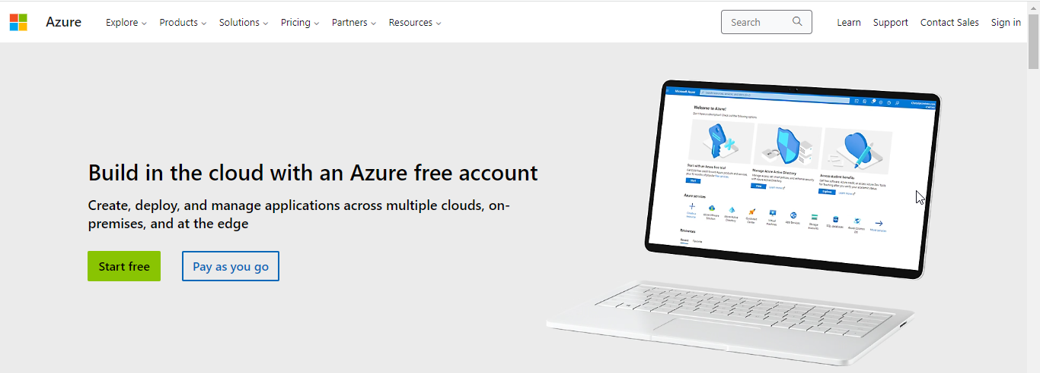

  - Sign in with the Microsoft or GitHub account or create a free Microsoft account

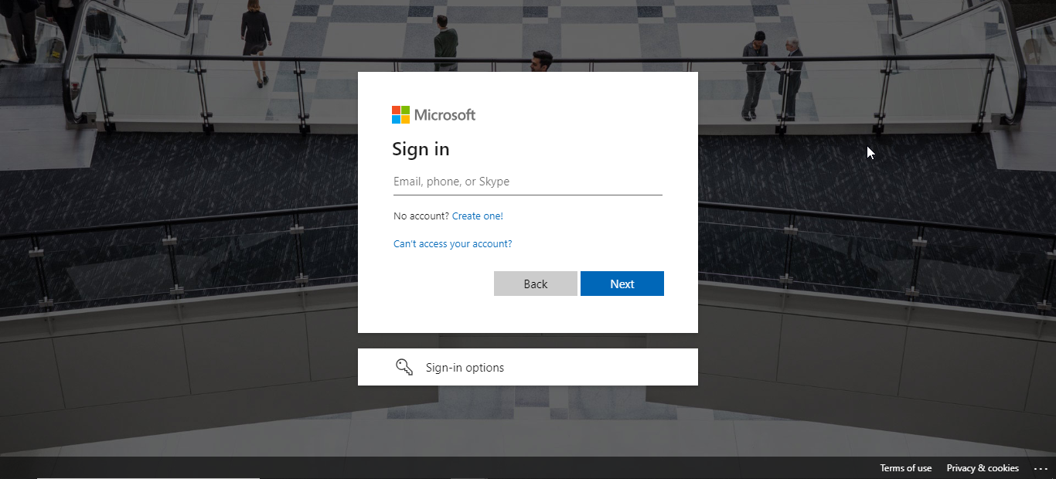

  - Under Your profile, select the Country/Region from the dropdown. Enter the First name and Last name, Email address, and Phone. Click on the Text me or Call me option to verify the phone number.

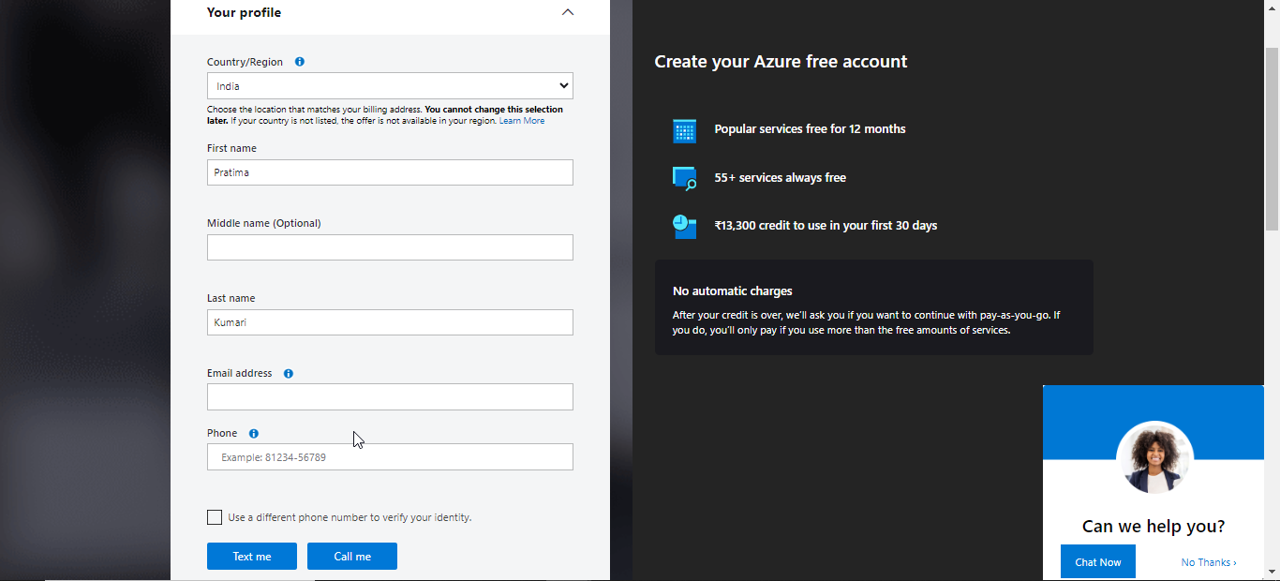

  - Fill in the remaining details as shown and click Next to continue.

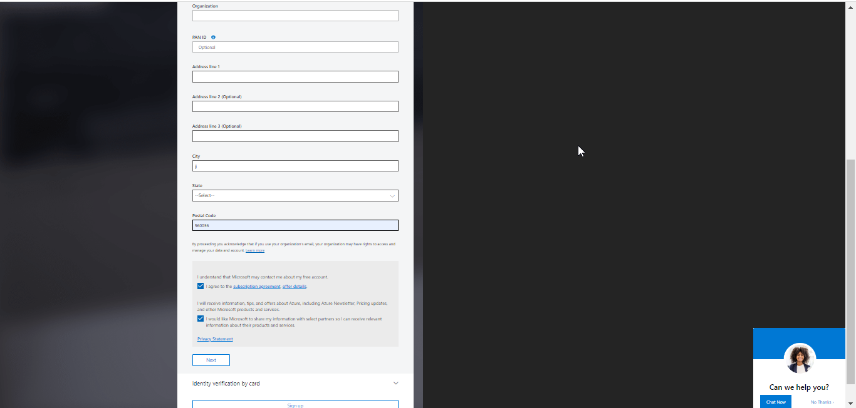

  - Enter the card details and click Next

  - Review the Agreement and privacy statement, then select Sign up

You have effectively established a free account and should now be redirected to the Azure portal's home page.

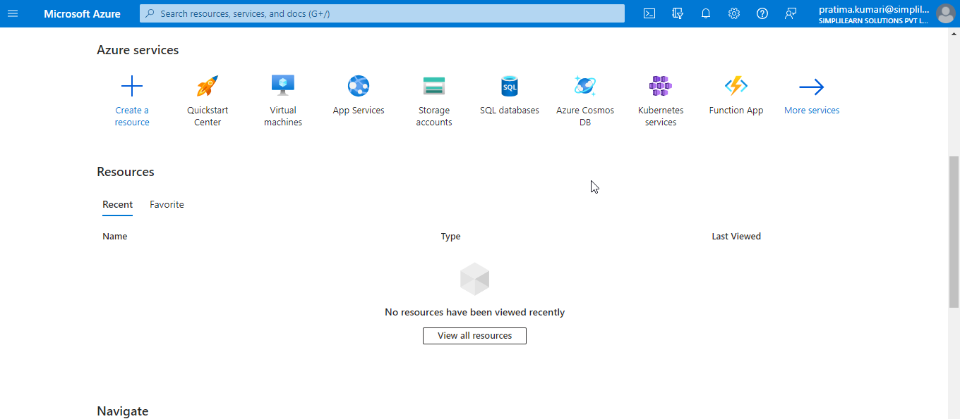

Step 2: Create a resource group

- On the Azure portal, click on + Create a resource

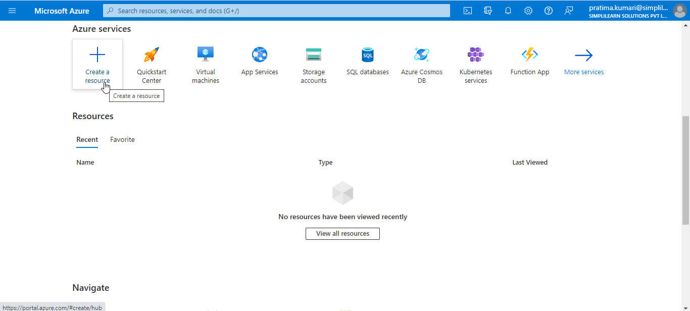

- Search for the Resource group

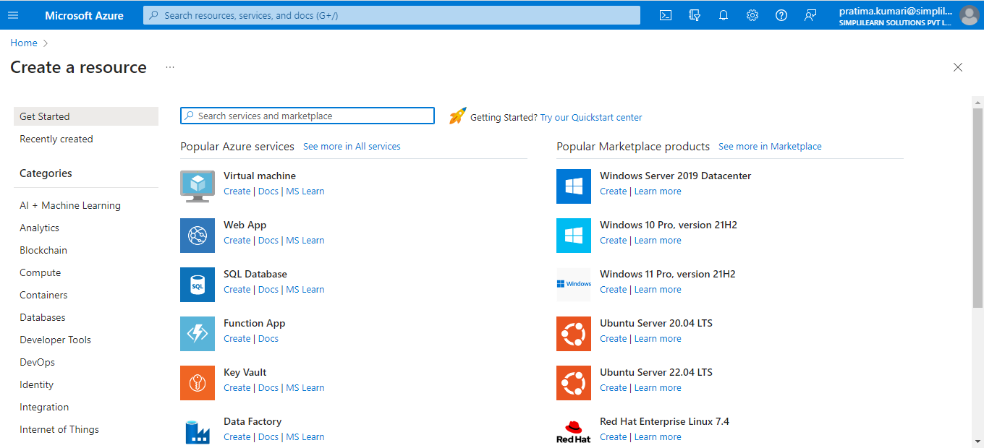

- In the Resource Group creation page, click on Create

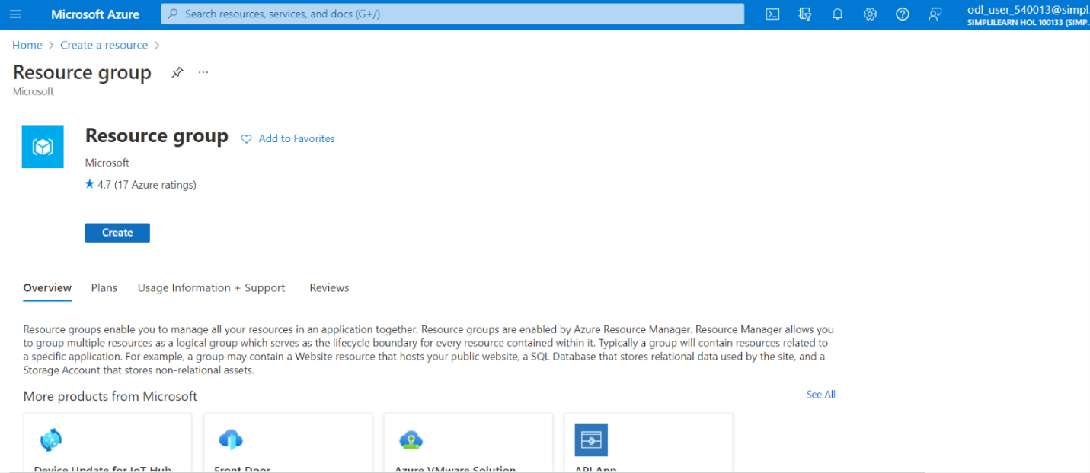

- In the Basics tab, provide the Resource group under the Project details and choose a Region from the dropdown

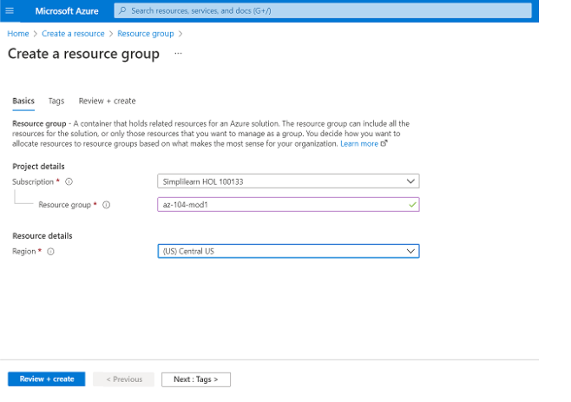

- Click on Review + create button



- Click on Create; the resource group is created successfully.

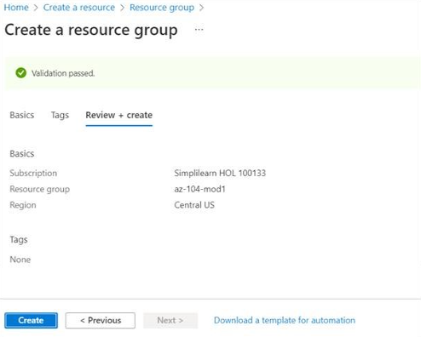
You have now successfully created a Microsoft Azure free account and a resource group.

